Guided Inquiry Activity: Exploring Thermodynamic States Using Steam Tables

Learning Objectives
By the end of this activity, you should be able to:
- Identify the thermodynamic state of a substance (subcooled liquid, saturated mixture, or superheated vapor) using two independent properties.
- Explain why Temperature () and Pressure () are not independent variables inside the saturation dome.
- Quantify and explain physical changes in specific volume (), enthalpy (), and entropy () during liquid-to-vapor phase transitions.
- Relate phase change properties to the molecular behavior of water.

Model 1: The Saturation Dome and Phase Boundaries
Imagine heating liquid water in a piston-cylinder device at a constant pressure. As heat is added, the temperature rises until boiling begins. During boiling, the temperature remains constant as the liquid changes to vapor. Once all liquid has turned to vapor, further heating increases the temperature.
Refer to the - (Temperature-Entropy) diagram generated in the Steam Table Calculator web app to answer the following questions.

Critical Thinking Questions (Model 1)
- Locate the blue line (left side of the dome) and the red line (right side of the dome) on the - diagram.
  - What state of water does the blue curve () represent?
  - What state of water does the red curve () represent?
- Locate the "tie-line" (the dashed horizontal line connecting the blue and red curves) on the diagram.
  - What physical process occurs along this line?
  - How do temperature and pressure change as you move from left to right across this line?
- Using the Steam Table Calculator, load the preset Saturated Standard Boiling Point (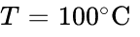, 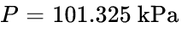).
  - What are the values of Specific Volume for saturated liquid () and saturated vapor ()?
  - By what factor does the volume expand when water evaporates at this condition? (Calculate 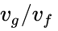).

Model 2: The Phase Rule and Independence of Properties
According to the Gibbs Phase Rule, the number of independent, intensive properties needed to completely fix the state of a pure substance is:

Where is the number of chemical species (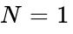 for water) and is the number of phases in equilibrium.

Critical Thinking Questions (Model 2)
- For a single-phase region (e.g., subcooled liquid or superheated vapor, where 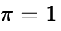):
  - How many independent properties () are needed to fix the state?
  - If you specify 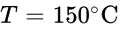 and 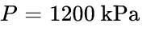 (Subcooled), are these two properties independent? Why or why not?
- For a two-phase saturated mixture (where liquid and vapor coexist, so 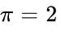):
  - How many independent properties () are needed to fix the thermodynamic state?
  - Try setting  and  in the calculator. Now, try setting  and 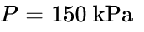 in the calculator.
  - Explain why specifying both and inside the saturation dome fails to uniquely define a single phase or state of wet steam.
- If you are given , what other properties could you specify (instead of Pressure) to successfully fix the exact thermodynamic properties of a saturated mixture?

Model 3: Energy and Volume Changes Across the Saturation Dome
Let's analyze how the differences between saturated liquid and saturated vapor properties (such as 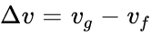 and 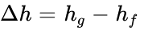) behave as system conditions change.
Use the calculator to lookup values at the temperatures listed below. Keep the units in SI Metric (bar/kPa, 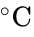, kJ/kg, m³/kg).
Temp (T) [∘C] | Sat. Pressure (P) [kPa] | Liquid Enthalpy (hf​) [kJ/kg] | Vapor Enthalpy (hg​) [kJ/kg] | Enthalpy of Vaporization (hfg​=hg​−hf​)
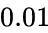
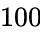 | 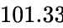 | 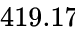 | 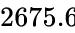 | 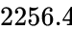
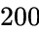
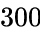
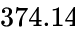

Critical Thinking Questions (Model 3)
- Fill out the table using the calculator's Underlying Reference Saturation Boundary Data view.
- As the temperature and pressure increase toward the critical point (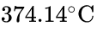):
  - What happens to the energy required to vaporize the water (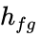)?
  - Explain this trend in terms of molecular forces. (Hint: Think about how intermolecular spacing behaves as you approach the critical state).
- At the Critical Point (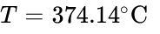):
  - What is the value of ?
  - What is the physical difference between the liquid phase and the vapor phase at this state?

Model 4: The Entropy of Phase Change
Entropy () measures the dispersion of energy at a specific temperature. For a reversible phase change occurring at constant temperature, the change in entropy is defined as:

where 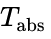 is the absolute temperature in Kelvin (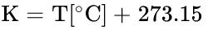).

Critical Thinking Questions (Model 4)
- Let us test this equation for water boiling at standard atmospheric pressure.
  - Look up 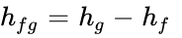 and 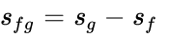 at .
  - Convert  to Kelvin: $T_{\text{abs}} = $ ____________ .
  - Calculate 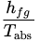. How does this value compare to the steam table's value of 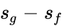?
- Compare the entropy of vaporization (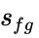) at 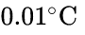 to the value at 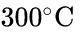.
  - Why is the increase in molecular disorder (entropy) so much larger when liquid water evaporates at a low temperature compared to a high temperature?

Application Exercises
Use your Steam Table Calculator to diagnose the states and solve the following real-world engineering scenarios:
- Boiler Feedwater Preheater: Water enters a heater at  and .
  - What phase is this water in?
  - What is the specific enthalpy () of this water? (Hint: Does liquid water properties depend more on temperature or pressure?)
- Geothermal Power Plant: A geothermal well produces wet steam at a pressure of 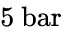 (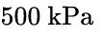).
  - What is the saturation temperature of this steam? (Convert output unit to  or 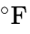 as requested by your instructor).
  - If a moisture separator splits this stream, what are the enthalpies of the pure liquid stream () and the pure dry steam stream ()?
- Steam Turbine Exhaust: Superheated steam expands through a turbine and exits at 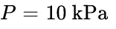 with an entropy of 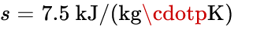.
  - Is the exhaust steam subcooled, superheated, or saturated? Explain how you determined this using the saturation entropy limits ( and ) at 

